Name: Krishna Pandey

Adm no: U20CS110

|  |  |  |  |  |
| --- | --- | --- | --- | --- |
| **Expt. No:** | | **3** |  | **COMMON EMITTER CHARACTERISTICS** |
| **Date:** | **23/8/2021** | |  |
|  | | | | |

**AIM:** To study, the Input-Output characteristics of a bipolar junction transistor in Common Emitter Configuration.

SOFTWARE TOOLS / OTHER REQUIREMENTS:

1. Multisim Simulator/Circuit Simulator

THEORY:

A transistor is a semiconductor device used to amplify or switch electronic signals and electrical power. Transistors are one of the basic building blocks of modern electronics. It is composed of semiconductor material usually with at least three terminals for connection to an external circuit.

The transistor is a three-layer semiconductor device consisting of either two ntype and one p-type layers of material or two p-type and one n-type layers of material. The former is called a npn transistor, and the latter is called a pnp transistor.

The most frequently encountered transistor configuration appears in figure for the pnp and npn transistors. It is called the common-emitter configuration because the emitter is common to both the input and output terminals (in this case common to both the base and collector terminals). Two sets of characteristics are again necessary to describe fully the behavior of the common emitter configuration: one for the input or base–emitter circuit and one for the output or collector–emitter circuit.



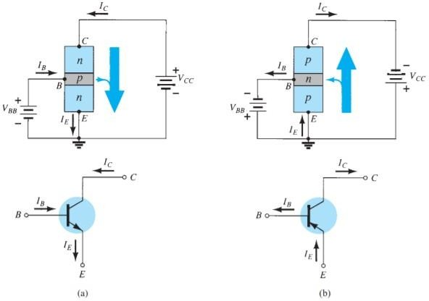

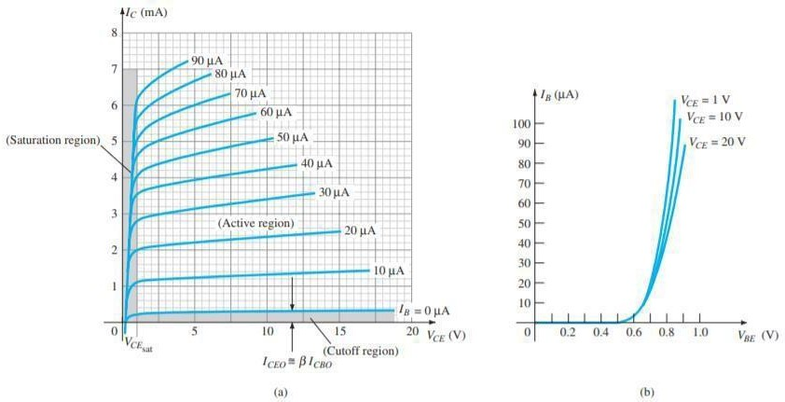***Figure (a)npn transistor and (b)pnp transistor***

***Characteristics of a Silicon transistor in the common-emitter configuration: (a)collector characteristics and (b)base characteristics***

Note that on the characteristics of figure the magnitude of IB is in microamperes, compared to milli-amperes of IC. Consider also that the curves of IB are not as horizontal as those obtained for IE in the common-base configuration, indicating that the collector-to-emitter voltage will influence the magnitude of the collector current. The active region for the common-emitter configuration is that portion of the upper-right quadrant that has the greatest linearity, that is, that region in which the curves for IB are nearly straight and equally spaced. In figure(a) this region exists to the right of the vertical dashed line at VCE sat and above the

curve for IB equal to zero. The region to the left of VCE sat is called the saturation region. In the active region of a common-emitter amplifier, the base– emitter junction is forward-biased, whereas the collector–base junction is reverse-biased.

INPUT CHARACTERISTICS:

The input characteristics are a plot of the input current (IB) versus the input voltage (VBE) for a range of values of output voltage (VCE). The curve describes the changes in the values of input current with respect to the values of input voltage keeping the output voltage constant.

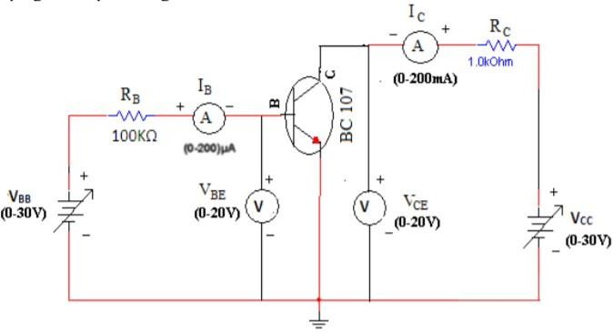

PROCEDURE:

Connect the circuit as shown in the circuit diagram.

* Keep output voltage VCE = 1V by adjusting VCC.
* Varying VBB gradually, note down base current IB and base-emitter voltage VBE.
* Step size is not fixed because of non-linear curve. Initially vary VBB in steps of 0.1V. Once the current starts increasing vary VBB in steps of 1V up to 5V.
* Repeat above procedure (step 3) for VCE = 1V and 5V.

OUTPUT CHARACTERISTICS: 

The output characteristics are a plot of the output current (IC) versus output voltage (VCE) for a range of values of input current (IB). The curve describes the changes in the values of output current against output voltage keeping the input current constant.

PROCEDURE:

* Connect the circuit as shown in the circuit diagram.
* Set the emitter current IB = 10μA by varying VBB.
* Varying VCC gradually in steps of 1V up to 10V and note down collector current IC and collector-emitter voltage (VCE).
* Repeat above procedure (step 3) for IB = 20μA and 50μA

INPUT/OUTPUT CHARACTERISTICS:

INPUT CIRCUIT/CONNECTION DIAGRAMS (FROM MULTISIM):

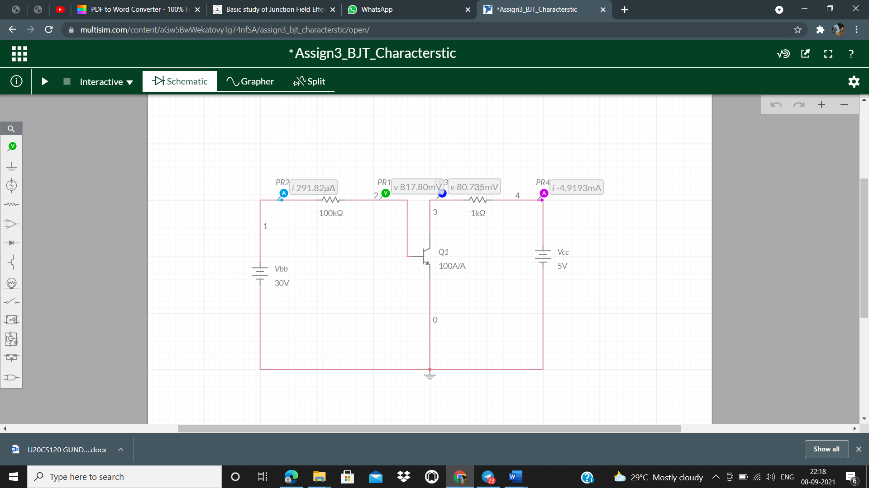

OBSERVATION TABLE 1:

|  |  |  |  |  |  |  |
| --- | --- | --- | --- | --- | --- | --- |
| **Vbb (in volts)** | **Vce= 1V** | | **Vce= 2V** | | **Vce= 5V** | |
| **Vbe (in volts)** | **Ib** | **Vbe** | **Ib** | **Vbe** | **Ib** |
| 0 | 0 | 0 | 0 | 0 | 0 | 0 |
| 0.1 | 0.1 | 0 | 0.1 | 0 | 0.1 | 0 |
| 0.2 | 0.2 | 0 | 0.2 | 0 | 0.2 | 0 |

|  |  |  |  |  |  |  |
| --- | --- | --- | --- | --- | --- | --- |
| 0.3 | 0.3 | 0 | 0.3 | 0 | 0.3 | 0 |
| 0.4 | 0.4 | 0 | 0.4 | 0 | 0.4 | 0 |
| 0.5 | 0.49998 | 0 | 0.49998 | 0 | 0.49998 | 0 |
| 0.6 | 0.59886 | 0.01137 | 0.59886 | 0.01137 | 0.59886 | 0.01137 |
| 0.7 | 0.67683 | 0.23169 | 0.67683 | 0.23169 | 0.67683 | 0.23169 |
| 0.8 | 0.71150 | 0.88505 | 0.71150 | 0.88505 | 0.71150 | 0.88505 |
| 0.9 | 0.72859 | 1.7141 | 0.72859 | 1.7141 | 0.72859 | 1.7141 |
| 1.0 | 0.73942 | 2.6058 | 0.73942 | 2.6058 | 0.73942 | 2.6058 |
| 1.5 | 0.76613 | 7.3387 | 0.76620 | 7.338 | 0.76620 | 7.338 |
| 2.0 | 0.77048 | 12.295 | 0.77936 | 12.206 | 0.77936 | 12.206 |
| 2.5 | 0.77136 | 17.286 | 0.78808 | 17.119 | 0.78811 | 17.119 |
| 3.0 | 0.77195 | 22.280 | 0.79007 | 22.099 | 0.79466 | 22.053 |
| 3.5 | 0.77243 | 27.276 | 0.79049 | 27.095 | 0.79990 | 27.001 |
| 4.0 | 0.77286 | 32.271 | 0.79078 | 32.092 | 0.80426 | 31.957 |
| 4.5 | 0.77324 | 37.268 | 0.79101 | 37.09 | 0.80799 | 36.920 |
| 5.0 | 0.77361 | 42.264 | 0.79122 | 42.088 | 0.81126 | 41.887 |
|  |  |  |  |  |  |  |
|  |  |  |  |  |  |  |
|  |  |  |  |  |  |  |
|  |  |  |  |  |  |  |

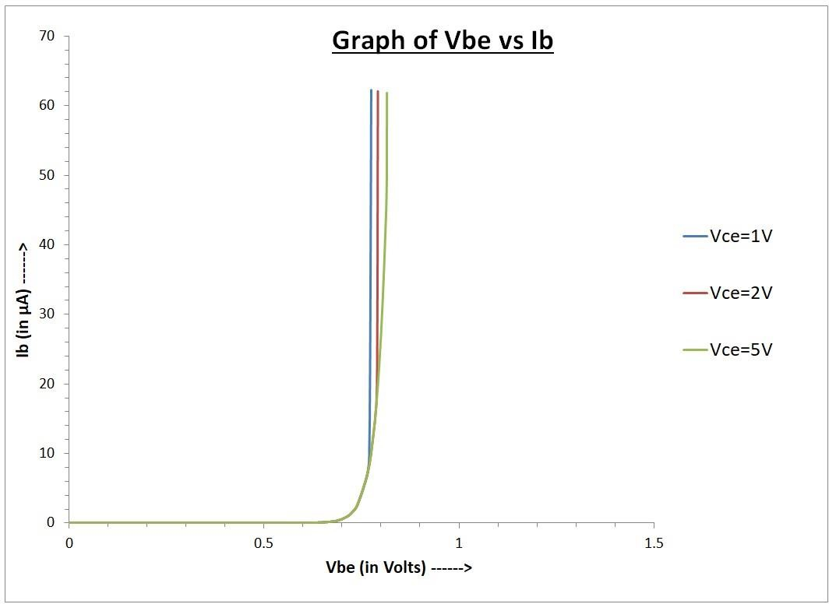GRAPH 1:

INPUT CIRCUIT/CONNECTION DIAGRAMS (FROM MULTISIM):



OBSERVATION TABLE 2:



|  |  |  |  |  |  |  |
| --- | --- | --- | --- | --- | --- | --- |
| **VCC**  **(Volts)** | **IB=10μA** | | **IB=20μA** | | **IB=50μA** | |
| **VCE (In**  **Volts)** | **IC**  **(In mA)** | **VCE** | **IC** | **VCE** | **IC** | **VCE** |
| 0 | 0.00691 | 0.00691 | 0.01021 | 0.01021 | 0.01396 | 0.01396 |
| 0.1 | 0.05111 | 0.04889 | 0.04186 | 0.05814 | 0.03174 | 0.06826 |
| 0.2 | 0.07301 | 0.12699 | 0.05888 | 0.14112 | 0.04315 | 0.15685 |
| 0.3 | 0.08749 | 0.21251 | 0.07043 | 0.22957 | 0.05154 | 0.24846 |
| 0.4 | 0.09880 | 0.30120 | 0.07939 | 0.32071 | 0.05818 | 0.34182 |
| 0.5 | 0.10897 | 0.39103 | 0.08661 | 0.41339 | 0.06372 | 0.43627 |
| 0.6 | 0.11809 | 0.48191 | 0.09310 | 0.50690 | 0.06885 | 0.53150 |
| 0.7 | 0.12755 | 0.57245 | 0.09891 | 0.60109 | 0.07272 | 0.62728 |
| 0.8 | 0.13692 | 0.66308 | 0.10429 | 0.69571 | 0.07650 | 0.72350 |
| 0.9 | 0.14815 | 0.75185 | 0.10937 | 0.79063 | 0.07996 | 0.82004 |
| 1.0 | 0.16150 | 0.83785 | 0.11431 | 0.88569 | 0.08315 | 0.91685 |
| 1.2 | 0.21677 | 0.98323 | 0.12401 | 1.07600 | 0.08893 | 1.11110 |
| 1.4 | 0.39438 | 1.00560 | 0.13400 | 1.26600 | 0.09412 | 1.30590 |
| 1.6 | 0.59435 | 1.00560 | 0.14520 | 1.45480 | 0.09889 | 1.50110 |
| 1.8 | - | - | 0.15304 | 1.64100 | 0.10336 | 1.69660 |
| 2.0 | - | - | 0.17955 | 1.82050 | 0.10761 | 1.89240 |
| 2.4 | - | - | 0.39919 | 2.00090 | 0.11574 | 2.28430 |

|  |  |  |  |  |  |  |
| --- | --- | --- | --- | --- | --- | --- |
| 2.8 | - | - | 0.79915 | 2.00090 | 0.12371 | 2.67630 |
| 3.2 | - | - | - | - | 0.13190 | 3.06810 |
| 3.6 | - | - | - | - | 0.14376 | 3.45920 |
| 4.0 | - | - | - | - | 0.14600 | 3.38490 |
| 4.4 | - | - | - | - | 0.16400 | 4.23600 |
| 4.8 | - | - | - | - | 0.18397 | 4.61600 |
| 5.2 | - | - | - | - | 0.24249 | 4.75750 |
| 5.6 | - | - | - | - | 0.59984 | 5.00020 |
| 6.0 | - | - | - | - | 0.99984 | 5.00020 |

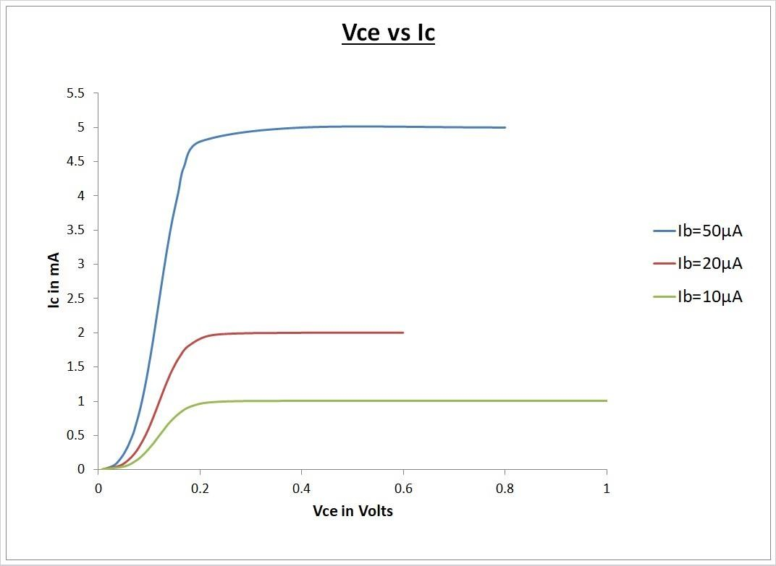GRAPH 2:

CONCLUSIONS:

We can get the saturation value of the collector current (Ic) with increasing voltage for different base current (Ib). And we can also note the variation of the maximum saturation value of collector current for the change in the constant base current. Also, we can determine the Q-point of a transistor for a particular biasing configuration from the output characteristics.

The curve for the common emitter characteristics is similar to a forward diode characteristic. The base current IB increases with increase in the emitter-base voltage VBE. In the active region of a common-emitter amplifier, the base-emitter junction is forward-biased, whereas the collector-base junction is reverse-biased.

These amplifiers are used typically in the RF circuits. The common emitter circuit is popular because it’s well-suited for voltage amplification, especially at low frequencies.

Common-emitter amplifiers are also used in radio frequency transceiver circuits.

